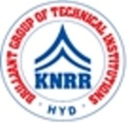 | KASIREDDY NARAYANREDDY COLLEGE OF ENGINEERING & RESEARCH.  (Approved by AICTE & Affiliated to JNTUH)  Abdullapur (V), Abdullapurmet (M), R.R Dist, 501505,Telangana, INDIA.  Email : principal@knrcer.ac.in ; website: www.knrcer.ac.in

6.3.3 Percentage of teaching and non-teaching staff participating in Faculty development Programmes (FDP), professional development /administrative training programs during the last five years

Topic | URL
List of professional development / administrative  training programs organized by the institution | View Document
Event Brochures and reports year-wise | View Document
 | View Document
List of participants in each programme | View Document
Photographs with date adaption | View Document
Annual reports highlighting the programs organized by the institution | View Document

