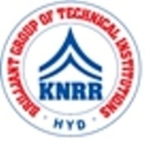 | KASIREDDY NARAYANREDDY COLLEGE OF ENGINEERING & RESEARCH.  (Approved by AICTE & Affiliated to JNTUH)  Abdullapur (V), Abdullapurmet (M), R.R Dist, 501505,Telangana, INDIA.  Email : principal@knrcer.ac.in ; website: www.knrcer.ac.in

6.3.2 Percentage of teachers provided with financial support to attendconferences/workshopsandtowardsmembershipfeeofprofessionalbodiesduring thelast fiveyears

Topic | URL
Policydocumentonprovidingfinancialsupporttoteachers | View Document
E-copy of letter/s indicating financial assistance to  teachersandlistofteachersreceivingfinancialsupport yearwise undereachhead. | 2a. View Document
 | 2b. View Document
Audited statement of account highlighting thefinancialsupporttoteacherstoattendconferences/workshop s and towards membership fee forprofessional bodies. | View Document

