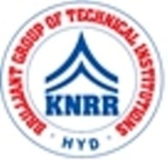 | KASIREDDY NARAYANREDDY COLLEGE OF ENGINEERING & RESEARCH.  (Approved by AICTE & Affiliated to JNTUH)  Abdullapur (V), Abdullapurmet (M), R.R Dist, 501505,Telangana, INDIA.  Email : principal@knrcer.ac.in ; website: www.knrcer.ac.in

Percentage of expenditure incurred on maintenance of infrastructure (physical and academic support facilities) excluding salary component during the last five years (INR in Lakhs)

Expenditure incurred on maintenance of infrastructure (physical facilities and academic support facilities) excluding salary component year wise during the last five years (INR in lakhs)

1. Highlighting the items of expenditure incurred on maintenance of physical facilities and academic support facilities, duly certified by Head of the Institution and CA.

PARTICULAR | URL
Highlighting the items of expenditure incurred on maintenance of physical facilities and academic  support facilities | View Document

