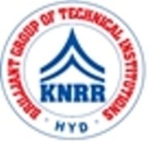 | KASIREDDY NARAYANREDDY COLLEGE OF ENGINEERING & RESEARCH.  (Approved by AICTE & Affiliated to JNTUH)  Abdullapur (V), Abdullapurmet (M), R.R Dist, 501505,Telangana, INDIA.  Email : principal@knrcer.ac.in ; website: www.knrcer.ac.in

Student – Computer ratio (Data for the latest completed academic year)
Number of computers available for students usage during the latest completed academic year

- Number of Computers available for student use only.

PARTICULAR | URL
Number of Computers available for student use only. | View Document

- Bills for the purchase of computers.

PARTICULAR | URL
Bills for the purchase of computers | View Document

- Highlighting the entries of computers purchased in the stock registers.

PARTICULAR | URL
Highlighting the entries of computers purchased in the stock registers | View Document

