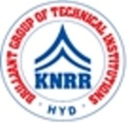 | KASIREDDY NARAYANREDDY COLLEGE OF ENGINEERING & RESEARCH.  (Approved by AICTE & Affiliated to JNTUH)  Abdullapur (V), Abdullapurmet (M), R.R Dist, 501505,Telangana, INDIA.  Email : principal@knrcer.ac.in ; website: www.knrcer.ac.in

3.4.3Number of extension and outreach Programs conducted in collaboration with industry, community, and Non- Government Organizations through NSS/ NCC/ Red Cross/ YRC etc., year wise during the last five years

- Geo tagged Photographs and any other supporting document of relevance should have proper captions and dates

S.No | Description | URL
1 | Geo tagged Photographs and any other supporting document of relevance should have proper captions and dates | View Document

- Detailed report for each extension and outreach program to be made available, with specific mention of number of students participated and collaborating agency

S.No | Description | URL
1 | Detailed report for each extension and outreach program to be made available, with specific mention of number of students participated and collaborating agency | View Document

