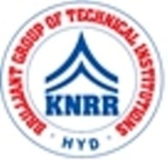 | KASIREDDY NARAYANREDDY COLLEGE OF ENGINEERING & RESEARCH.  (Approved by AICTE & Affiliated to JNTUH)  Abdullapur (V), Abdullapurmet (M), R.R Dist, 501505,Telangana, INDIA.  Email : principal@knrcer.ac.in ; website: www.knrcer.ac.in

3.2.2 Number of workshops/seminars/conferences including programs conducted on Research Methodology, Intellectual Property Rights (IPR) and entrepreneurship during the last five years.

S.No. | Descriptions | URL
1 | Detailed report for each program | View Document
2 | Brochure/ Geo tagged photograph with and Caption; Title of the workshops/ Seminars conducted | View Document
3 | Details of Resource persons with their contact details | View Document

