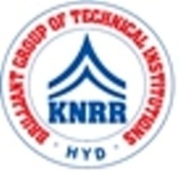 | KASIREDDY NARAYANREDDY COLLEGE OF ENGINEERING & RESEARCH.  (Approved by AICTE & Affiliated to JNTUH)  Abdullapur (V), Abdullapurmet (M), R.R Dist, 501505,Telangana, INDIA.  Email : principal@knrcer.ac.in ; website: www.knrcer.ac.in

1.List of grants for research projects received during the assessment years along with the nature
of the award, and the awarding agency with amount.(sanctioned letter highlighting the required
parts)

S.No | Description | URL
1 | List of grants for research projects received during the assessment years along with the nature of the award, and the Awarding agency with amount.(sanctioned letter highlighting the required parts) | View Document

2.E-copies of the letters of award for research projects sponsored by Government and non- government sources.

S.No | Description | URL
1 | E-copies of the letters of award for research projects | View Document

