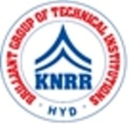 | KASIREDDY NARAYANREDDY COLLEGE OF ENGINEERING & RESEARCH.  (Approved by AICTE & Affiliated to JNTUH)  Abdullapur (V), Abdullapurmet (M), R.R Dist, 501505,Telangana, INDIA.  Email : principal@knrcer.ac.in ; website: www.knrcer.ac.in

2.6.2 Pass percentage of Students during last five years

DVV Finding | URL
1. Result sheet published by the affiliating university attested by the principal for fresh final year appeared students. | View Document

DVV Finding | URL
2. Certified report from Controller Examination of the affiliating university indicating pass percentage of students of the final year (final semester) | View Document

