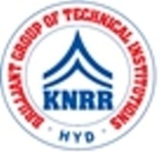 | KASIREDDY NARAYANREDDY COLLEGE OF ENGINEERING & RESEARCH.  (Approved by AICTE & Affiliated to JNTUH)  Abdullapur (V), Abdullapurmet (M), R.R Dist, 501505,Telangana, INDIA.  Email : principal@knrcer.ac.in ; website: www.knrcer.ac.in

2.4.2. Percentage of full time teachers with NET/SET/SLET/ Ph. D. / D.M. / M.Ch. / D.N.B Superspeciality / D.Sc. / D.Litt. during the last five years (consider only highest degree for count)

Particulars | Documents Enclosed
1. List of faculties having NET/SET/SLET/ Ph. D. / D.M.  / M.Ch. / D.N.B Superspeciality / D.Sc. / D.Litt. and any other post doctoral degree should be provide as per academic session wise along with particulars of degree awarding university, subject and the year of award. | View Document
2. Doctorate Degree awarded by UGC recognized universities only to be considered. | View Document

