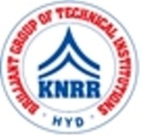 | KASIREDDY NARAYANREDDY COLLEGE OF ENGINEERING & RESEARCH.  (Approved by AICTE & Affiliated to JNTUH)  Abdullapur (V), Abdullapurmet (M), R.R Dist, 501505,Telangana, INDIA.  Email : principal@knrcer.ac.in ; website: www.knrcer.ac.in

2.4.1 Percentage of full-time teachers against sanctioned posts during the last five years

Particulars | Documents Enclosed
1. Sanction letters (in English) indicating number of posts (including Management sanctioned posts) by competent authority. | View Document
2. List of fulltime teachers appointed along with their departmental affiliation. | View Document

