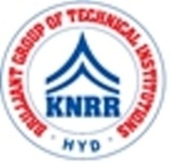 | KASIREDDY NARAYANREDDY COLLEGE OF ENGINEERING & RESEARCH.  (Approved by AICTE & Affiliated to JNTUH)  Abdullapur (V), Abdullapurmet (M), R.R Dist, 501505,Telangana, INDIA.  Email : principal@knrcer.ac.in ; website: www.knrcer.ac.in

2.1.2 Percentage of seats filled against seats reserved for various categories (SC, ST, OBC, Divyangjan, etc. as per applicable reservation policy) during the last five years (Exclusive of supernumerary seats)

Particulars | Documents Enclosed
1. Copy of letter issued by state govt. or Central Government indicating the reserved categories to be considered as per the state rule (in English as applicable) | View Document
2. Final admission list of first year students indicating their category published by the HEI and signed by the principal to be provided. | View Document
3. Admission extract submitted to the state OBC, SC and ST cell every year for the first year students with seal and signature of the principal. | View Document
4. Number of seats earmarked for the reserved categories | View Document

